Lab 4 – Task 1 Report
Manual g, h, f Calculation for the First Three A* Expansions
Course: CAI601400 – Artificial Intelligence Student: Amina Mustafa – Roll No. 329

1. Problem Statement
A campus navigation system knows the travel cost so far and an estimate of the remaining cost. For the supplied campus graph, start S and goal G, compute g(n), h(n) and f(n) = g(n) + h(n) by hand for the first three A* expansions, list the remaining frontier after each expansion, show every arithmetic step and explain why the next node is selected. The result is then verified with a program.

2. Assumptions
- Start building is S and destination is G; edge weights are travel-time units.
- The supplied h values are abstract time estimates in the same units as the edges, not measured campus distances.
- Queue entries are (f, g, node, path), as in the supplied A* code: the smallest f leaves first; a tie is broken by smaller g, then node name. Successors are generated in the listed order.
- An expansion means a node is removed from the queue and its successors are examined; the goal is not expanded.

3. Graph and Heuristic

3.1 Edges (travel time)
From | To | Cost
S | A | 1
S | B | 4
A | C | 2
B | G | 5
C | G | 3

Complete routes: S→A→C→G = 1 + 2 + 3 = 6; S→B→G = 4 + 5 = 9. The cheapest route is S→A→C→G with cost 6.

3.2 Heuristic values and true remaining cost
Node | h(n) | True remaining cost | h(n) ≤ true?
S | 5 | 6 | Yes
A | 4 | 5 | Yes
B | 4 | 5 | Yes
C | 2 | 3 | Yes
G | 0 | 0 | Yes

No h value is above the true remaining cost, so the heuristic is admissible on this graph (verified explicitly).

4. Evaluation Function
f(n) = g(n) + h(n) where g(n) is the cost from S to n along the best known path, h(n) is the estimated cost from n to G, and f(n) is the estimated cost of the cheapest route through n. A* always expands the frontier node with the smallest f.

5. Heuristic Audit

5.1 Consistency check: h(u) ≤ cost(u, v) + h(v)
Edge | Calculation | Result | Passes?
S → A | h(S) = 5 ≤ 1 + 4 = 5 | 5 ≤ 5 | Yes
S → B | h(S) = 5 ≤ 4 + 4 = 8 | 5 ≤ 8 | Yes
A → C | h(A) = 4 ≤ 2 + 2 = 4 | 4 ≤ 4 | Yes
B → G | h(B) = 4 ≤ 5 + 0 = 5 | 4 ≤ 5 | Yes
C → G | h(C) = 2 ≤ 3 + 0 = 3 | 2 ≤ 3 | Yes

Every edge passes, so the heuristic is consistent. Because of this, f(n) never decreases along a path, which is why the three expansions below have f = 5, 5, 5.

6. Manual Calculation of the First Three Expansions

Initial frontier
S(g = 0, h = 5, f = 0 + 5 = 5)

Expansion 1: select S
- Selected: S with g = 0, h = 5, f = 0 + 5 = 5 (only node in the frontier).
- Generate A: g = 0 + 1 = 1, h = 4, f = 1 + 4 = 5.
- Generate B: g = 0 + 4 = 4, h = 4, f = 4 + 4 = 8.
- Frontier: A(g=1, h=4, f=5), B(g=4, h=4, f=8).
- Next: A, because f(A) = 5 is smaller than f(B) = 8.

Expansion 2: select A
- Selected: A with g = 1, h = 4, f = 1 + 4 = 5.
- Generate C: g = 1 + 2 = 3, h = 2, f = 3 + 2 = 5.
- Frontier: C(g=3, h=2, f=5), B(g=4, h=4, f=8).
- Next: C, because f(C) = 5 is smaller than f(B) = 8.

Expansion 3: select C
- Selected: C with g = 3, h = 2, f = 3 + 2 = 5.
- Generate G: g = 3 + 3 = 6, h = 0, f = 6 + 0 = 6.
- Frontier: G(g=6, h=0, f=6), B(g=4, h=4, f=8).
- Next: G, because f(G) = 6 is smaller than f(B) = 8. When G is removed the search stops with path S → A → C → G and cost 6.

Summary table
Step | Selected | g | h | f | Frontier after expansion
1 | S | 0 | 5 | 5 | A(1,4,5), B(4,4,8)
2 | A | 1 | 4 | 5 | C(3,2,5), B(4,4,8)
3 | C | 3 | 2 | 5 | G(6,0,6), B(4,4,8)

8. Interpretation
- Why B waits: B has f = 8 for the whole trace. Its g = 4 is already high and h = 4 predicts more cost, so A* never expands it before G.
- Why f stays at 5: the heuristic is tight along S→A→C: each step adds exactly the cost that h lost, so f does not change until G, where f = 6 is the real total cost.
- Tie-breaking: no two frontier nodes had equal f at a selection point in these three steps, so the tie-break rule (smaller g, then name) was not needed.
- Compared with UCS: UCS orders by g only; here it would have to look at B(4) before G(6), while A* ignores B because f(B) = 8.

9. Edge Case / Failure Analysis
- Input: the same graph but with h(C) = 10 instead of 2 (true remaining cost of C is 3).
- Likely behaviour: f(C) = 3 + 10 = 13, which is larger than f(B) = 8, so A* would pick B and return the cost-9 route S→B→G instead of the optimal cost 6.
- Likely cause: h(C) overestimates the true remaining cost, so the admissibility condition fails and the optimality guarantee is lost.
- Proposed improvement: audit every h value against the true remaining cost (or check consistency edge by edge) before relying on A*. This overestimate is tested fully in Task 3.

10. Viva-Ready Design Explanation
- g(n) is the actual cost so far, h(n) is the estimate of the remaining cost, f(n) = g(n) + h(n) is the priority.
- Admissible: h(n) never exceeds the true remaining cost. Consistent: h(u) ≤ cost(u, v) + h(v) for every edge.
- The goal is tested when the node is removed from the queue, not when it is generated, so a cheaper route cannot be missed.
- A stale queue entry (g different from the best known g) is skipped.

11. Reflection
- What I learned: f combines real and estimated cost, and a good heuristic lets A* ignore nodes like B.
- What surprised me: f was 5 for the first three expansions, which shows how tight the heuristic is.
- Real AI use: map and campus navigation, where time estimates guide the search.
- Next time: test several heuristics and compare the number of expanded nodes.

12. Appendix: Python Code (Screenshots)
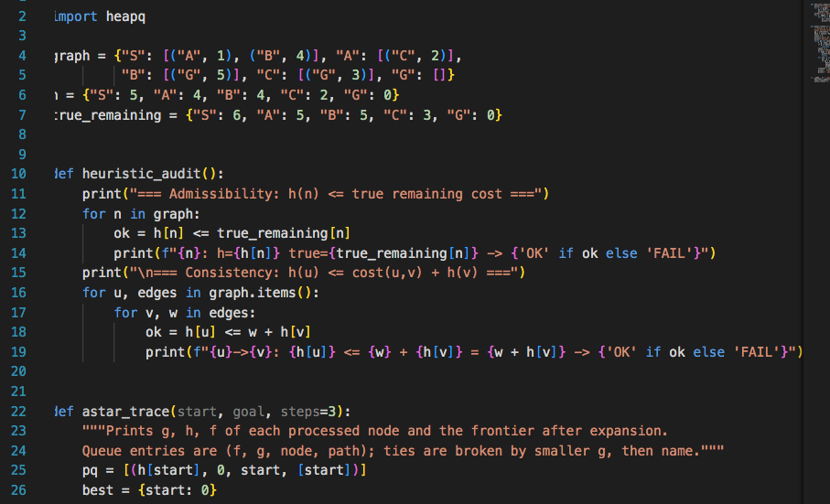
Figure 2: lab4_astar_audit.py – graph, heuristic and heuristic_audit()
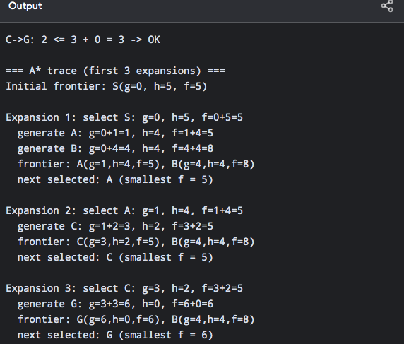
Figure 3: lab4_astar_audit.py – astar_trace() and main

Lab 4 – Task 2 Report
A* vs UCS: Path, Cost and Expanded-Node Comparison
Course: CAI601400 – Artificial Intelligence Student: Amina Mustafa – Roll No. 329

1. Problem Statement
Run A* with the supplied heuristic and a zero-heuristic UCS control on the same campus graph with the same start S and goal G. For each run record the returned path, the independently summed path cost, the processed-node trace and the expansion count, using one counting convention for both runs, and explain any stale-entry or goal-counting differences.

2. Assumptions and Counting Convention
- Graph, start (S), goal (G), successor order and tie-breaking are identical in both runs. Only the heuristic changes.
- Queue entries are (f, g, node, path); a tie is broken by smaller g, then by node name.
- Expanded node: a node whose successors are examined. The goal is logged when processed but is not counted as an expansion.
- Stale entries: an outdated queue entry (its g is larger than the best known g for that node) is ignored and not counted.
- The heuristic values are abstract time estimates, not measured distances.

3. Graph and Heuristics
Node | Edges out | h (A*) | h (UCS control) | True remaining
S | A(1), B(4) | 5 | 0 | 6
A | C(2) | 4 | 0 | 5
B | G(5) | 4 | 0 | 5
C | G(3) | 2 | 0 | 3
G | – | 0 | 0 | 0

Setting every h to zero turns f(n) = g(n) + h(n) into f(n) = g(n), so the same code becomes Uniform Cost Search.

4. Implementation Choices
- One function search(graph, h, start, goal) is used for both runs, so any difference in the result comes only from h.
- heapq is the priority queue. The goal test is done when a node is removed from the queue.
- path_cost() adds the edge weights of the returned path separately from the search to verify the cost independently.

6.1 A* trace (supplied heuristic)
Step | Processed | g | h | f | Frontier after expansion
1 | S (expanded) | 0 | 5 | 5 | A(5), B(8)
2 | A (expanded) | 1 | 4 | 5 | C(5), B(8)
3 | C (expanded) | 3 | 2 | 5 | G(6), B(8)
4 | G (goal) | 6 | 0 | 6 | Stop – not counted

6.2 UCS trace (h = 0 for all nodes)
Step | Processed | g | h | f | Frontier after expansion
1 | S (expanded) | 0 | 0 | 0 | A(1), B(4)
2 | A (expanded) | 1 | 0 | 1 | C(3), B(4)
3 | C (expanded) | 3 | 0 | 3 | B(4), G(6)
4 | B (expanded) | 4 | 0 | 4 | G(6)
5 | G (goal) | 6 | 0 | 6 | Stop – not counted

6.3 Comparison table
Run | Path | Cost | Expanded nodes | Processing order
A* | S → A → C → G | 6 | 3 (S, A, C) | S, A, C, G
UCS | S → A → C → G | 6 | 4 (S, A, C, B) | S, A, C, B, G

6.4 Independent cost verification
Path | Sum of edge weights | Total
S → A → C → G | w(S,A) + w(A,C) + w(C,G) = 1 + 2 + 3 | 6

The independent sum (6) equals the cost returned by both searches.

7. Interpretation
- Same answer: both runs return S → A → C → G with cost 6. The cheaper route is found by both because the heuristic is admissible and consistent (Task 1 audit).
- Fewer expansions with A*: A* expanded 3 nodes and UCS expanded 4. UCS expanded B because g(B) = 4 is smaller than g(G) = 6, even though B leads only to the costlier route. A* kept B in the frontier with f(B) = 4 + 4 = 8, which is larger than f(G) = 6, so B was never expanded.
- Stale entries: none occurred in either run (0 skipped), because each node was reached by a better cost only once. G is generated once, through C with g = 6; when B is expanded in UCS, the route B→G has g = 4 + 5 = 9, which is not better than 6 and is not added.
- Goal counting: the goal G is processed in both runs but excluded from the count, so the counts are 3 and 4 and not 4 and 5. If goal processing were included the difference would still be one node.
- Evidence limit: the saving (3 against 4 nodes) is measured on this one small graph. It shows A* helps here; it does not prove how much A* saves on other graphs.

8. Edge-Case Tests
Test | Result | Observation
Start equals goal (S, S) | Path [S], cost 0, 0 expanded | Goal test passes on the first pop.
Unreachable goal (isolated X) | No path, 5 nodes expanded | All reachable nodes are exhausted; no path is invented.

9. Failure / Edge Case Analysis
- Input: a heuristic that is worse than useful, such as h = 0 (the UCS control) on this graph.
- Observed behaviour: the path and cost stay optimal (6) but one extra node (B) is expanded.
- Likely cause: with no estimate of the remaining cost, the search orders only by g and cannot tell that B is irrelevant.
- Proposed improvement: use a heuristic close to the true remaining cost (but never above it). If the heuristic is changed, its admissibility must be re-checked; Task 3 shows an overestimate that makes the result wrong.

12. Appendix: Python Code (Screenshots)
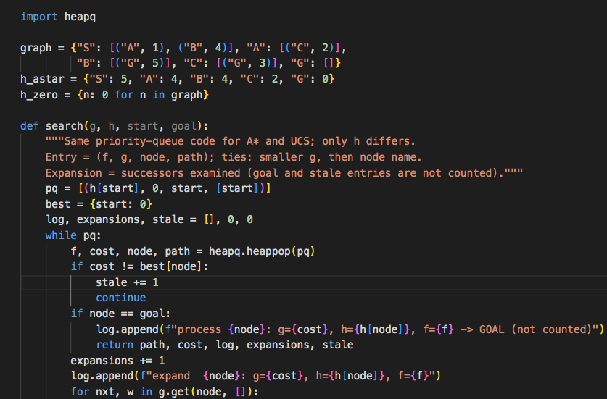
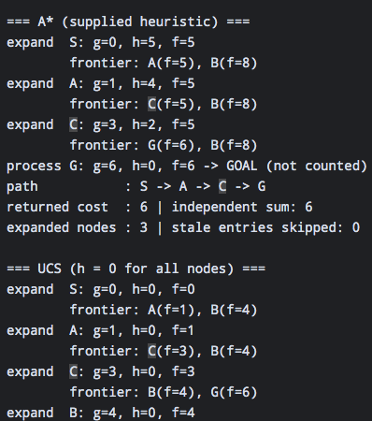

Lab 4 – Task 3 Report
Overestimating One Heuristic Value: The h(C) = 10 Experiment
Course: CAI601400 – Artificial Intelligence Student: Amina Mustafa – Roll No. 329

1. Problem Statement
Deliberately change one heuristic value of the campus graph so that it overestimates the true remaining cost, rerun A*, and report whether the path, cost and expansion count change. Then explain why an overestimate can remove the optimality guarantee even when a particular run looks unchanged.

2. Assumptions
- Same graph, start S, goal G, successor order and tie-breaking as in Tasks 1 and 2 (queue entry (f, g, node, path); ties by smaller g, then node name).
- Only one value is changed: h(C), from 2 to 10. All other h values, including h(G) = 0, stay the same.
- Expansion count follows the Task 2 convention: successors examined; the goal and stale entries are not counted.

3. Experiment Setup
Changed node | Original h | Modified h | True remaining | Overestimate by
C | 2 | 10 | 3 | 10 − 3 = 7

Why this breaks admissibility: the true remaining cost of C is w(C,G) = 3, but h(C) = 10 > 3, so h(C) overestimates. Consistency also fails on the edge C → G: h(C) = 10 ≤ 3 + h(G) = 3 is false.
Routes: S→A→C→G costs 1 + 2 + 3 = 6 (optimal); S→B→G costs 4 + 5 = 9.

4. Implementation Choices
- The same A* function is run on the original and the modified heuristic, so only h(C) differs.
- audit() checks every node against its true remaining cost and every edge for consistency.
- path_cost() sums the edge weights of the returned path independently of the search.
- A sweep of h(C) = 2 … 9 is added to show how the result depends on the size of the overestimate.
.py

6. Results

6.1 Manual f-values with h(C) = 10
Node | Calculation | f
S | g = 0, h = 5 → f = 0 + 5 | 5
A | g = 0 + 1 = 1, h = 4 → f = 1 + 4 | 5
B | g = 0 + 4 = 4, h = 4 → f = 4 + 4 | 8
C | g = 1 + 2 = 3, h = 10 → f = 3 + 10 | 13 (was 5)
G (via B) | g = 4 + 5 = 9, h = 0 → f = 9 + 0 | 9

6.2 Modified A* trace (h(C) = 10)
Step | Processed | g | h | f | Frontier after expansion
1 | S (expanded) | 0 | 5 | 5 | A(5), B(8)
2 | A (expanded) | 1 | 4 | 5 | B(8), C(13)
3 | B (expanded) | 4 | 4 | 8 | G(9), C(13)
4 | G (goal) | 9 | 0 | 9 | Stop – C never expanded

6.3 Original vs modified
Run | h(C) | Path | Cost | Expanded nodes | Order
Original | 2 | S → A → C → G | 6 | 3 (S, A, C) | S, A, C, G
Modified | 10 | S → B → G | 9 | 3 (S, A, B) | S, A, B, G

Independent cost check: original: 1 + 2 + 3 = 6; modified: w(S,B) + w(B,G) = 4 + 5 = 9. Both match the returned costs.

6.4 Sweep of h(C) (only h(C) changes)
h(C) | Admissible? | Path | Cost | Expanded nodes
2 | Yes | S → A → C → G | 6 | 3
3 | Yes | S → A → C → G | 6 | 3
4 | No | S → A → C → G | 6 | 3
5 | No | S → A → C → G | 6 | 3
6 | No | S → A → C → G | 6 | 4
7 | No | S → B → G | 9 | 3
8 | No | S → B → G | 9 | 3
9 | No | S → B → G | 9 | 3

7. Interpretation
- The result changed: with h(C) = 10 the returned path is S → B → G with cost 9 instead of the optimal S → A → C → G with cost 6, so the answer is 3 units worse.
- Why: the inflated estimate made f(C) = 3 + 10 = 13. The frontier then held B(8) and C(13), so B was expanded first and produced G with f = 9. G(9) is smaller than C(13), so G was removed and the search stopped before C’s cheap continuation (C → G with total 6) was ever examined.
- The expansion count did not change: it stayed at 3 in both runs, but the nodes differ (C replaced by B). A count alone therefore cannot show that the answer became wrong; the path and the independently summed cost must be checked.
- Why an unchanged run proves nothing: h(C) = 4 and 5 also overestimate (true cost 3) but still return the optimal cost 6, because f(C) = 7 or 8 stays small enough for C to be expanded before G is removed. At h(C) = 6 the cost is still 6 but one more node is expanded. Only from h(C) = 7 does the answer go wrong. Whether an overestimate breaks the result depends on the graph and on how large the error is, so one correct run does not show that a heuristic is safe.
- Why the guarantee is lost: A* is guaranteed optimal when it removes the goal only after every cheaper route has f ≤ the goal’s cost. This needs h never to exceed the true remaining cost. An overestimate can push the f-value of a node on the optimal route above the cost of a worse complete route, hiding that node behind the goal.

8. Edge-Case Tests
Test | Result | Observation
h(C) = 3 (equal to true cost) | Optimal path, cost 6 | Exact heuristic is still admissible.
h(C) = 6 (largest harmless overestimate here) | Cost 6 but 4 nodes expanded | Answer preserved; efficiency lost.
h(C) = 7 (smallest harmful overestimate here) | Path S → B → G, cost 9 | Optimality lost.

9. Failure / Edge Case Analysis
- Input: original graph with h(C) changed from 2 to 10.
- Observed behaviour: A* returned S → B → G with cost 9 instead of cost 6; expansion count stayed 3.
- Likely cause: h(C) = 10 is larger than the true remaining cost 3, which violates admissibility (and consistency on C → G), so f(C) = 13 wrongly ranks C behind the goal.
- Proposed improvement: audit every heuristic value against the true remaining cost (or check consistency for each edge) before using A*, and compare the returned cost with a UCS control run. A UCS run (h = 0) would return cost 6 and expose the error.

12. Appendix: Python Code (Screenshots)
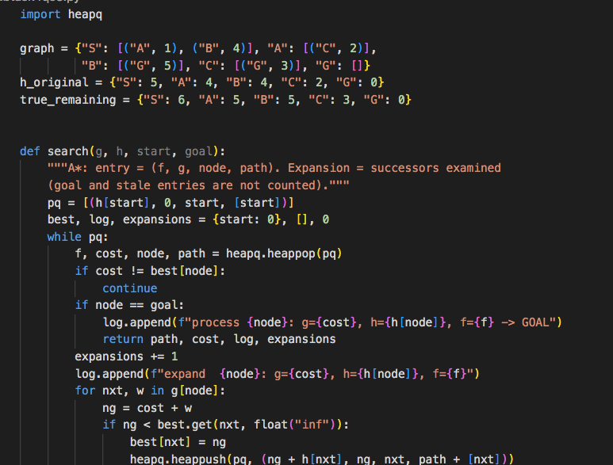
Figure 2: lab4_astar_overestimate.py – graph, search(), path_cost() and audit()
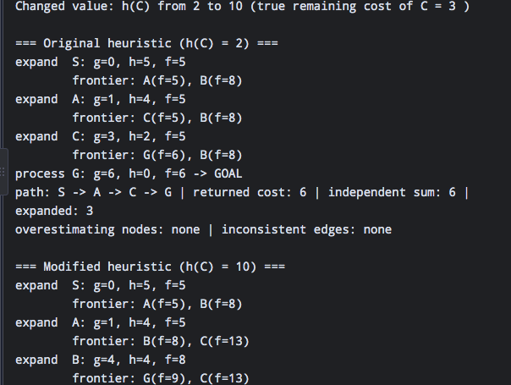
Figure 3: lab4_astar_overestimate.py – run() and test driver

